Press Office 4th August 2021
GREEN PASS FOR THE SPECTATORS
OF THE 98TH ARENA DI VERONA OPERA FESTIVAL 2021
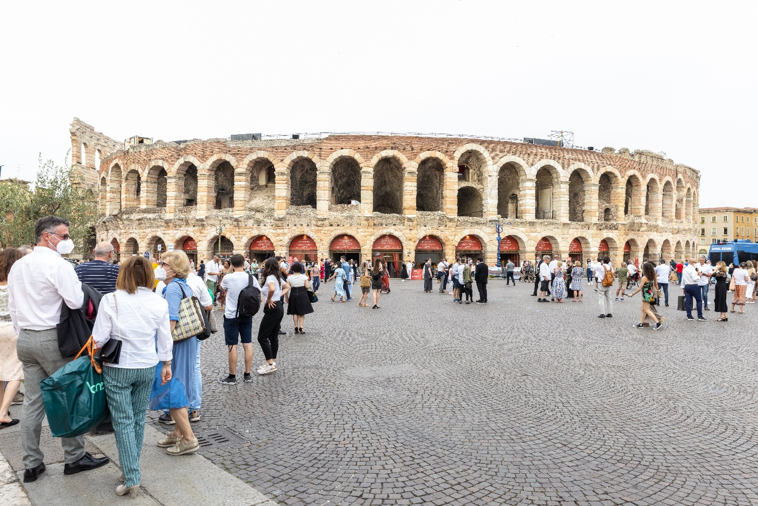

Arena 2021 © Laura Ferrari
From August 6th, pursuant to Article 3 of Legislative Decree 23rd July 2021 n. 105, access to the performances of Fondazione Arena di Verona will be allowed only to spectators with a Green Pass - EU Digital Covid Certificate or other certificate recognized by law.

The Green Pass, EU Digital Covid Certificate, is a digital and printable certification, issued by the national platform of the Ministry of Health, which has a QR Code to verify its authenticity and validity. You can get the Green Pass with:
- A dose of Covid-19 vaccine;
- The completed Covid-19 vaccination course;
- Certificate of a rapid molecular or antigen test with a negative result for the Sars-Cov-2 virus, carried out no later than 48 hours prior to the show;
- Certificate certifying that you have been healed from Covid-19 in the last 6 months.

Children under the age of 12 and those who have a suitable medical certification issued according to the criteria defined in the circular of the Ministry of Health are exempt from the obligation of the Green Pass.

In order to solve delays in obtaining the Green Pass - EU Digital Covid Certificate, until August 12th access to the Arena will be allowed also with other certificates recognized by law: vaccination certificate, test certificate, certificate of recovery.

Fondazione Arena di Verona has organized the verification service of individual Green Passes at the entrances to the Arena, in order to facilitate, as much as possible, access and to avoid crowds.
However, to allow the verification services to be carried out in time for the beginning of the performance, the audience must arrive at the entrances of the Arena corresponding to the admission ticket well in advance (at least 90 minutes before the start of the performance).
The gates open at 6.30 p.m.
Those who arrive late at the Arena or without a Green Pass will not be admitted inside the Arena without the right to a refund of the admission ticket.

For citizens of NON-EU countries, according to the circular of the Ministry of Foreign Affairs, vaccination certificates are also valid as long as they are written in one of the following languages: Italian, English, French, Spanish.
If the certificate is not issued in one of the four languages indicated, it must be accompanied by a sworn translation. The vaccines currently accepted in Italy and authorized by EMA are: Comirnaty (Pfizer-BioNtech); Spikevax (Modern); Vaxzevria (AstraZeneca); Janssen (Johnson & Johnson).
For further info, visit our website at https://www.arena.it/it/arena-di-verona/info-covid.

Info
Press Office Fondazione Arena di Verona
Via Roma 7/D, 37121 Verona
tel. (+39) 045 805.1861-1905-1891-1939-1847
ufficio.stampa@arenadiverona.it - www.arena.it

Ticket Office
Via Dietro Anfiteatro 6/B, 37121 Verona
tel. (+39) 045 59.65.17 - fax (+39) 045 801.3287
biglietteria@arenadiverona.it - www.arena.it
Call center (+39) 045 800.51.51
Pre-sale Geticket

