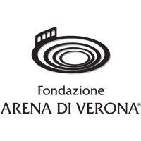

PRESS RELEASE

FONDAZIONE ARENA DI VERONA and BALICH WONDER STUDIO
PRESENT

“VIVA VIVALDI.
THE FOUR SEASONS IMMERSIVE CONCERT”
28 AUGUST AT THE ARENA DI VERONA

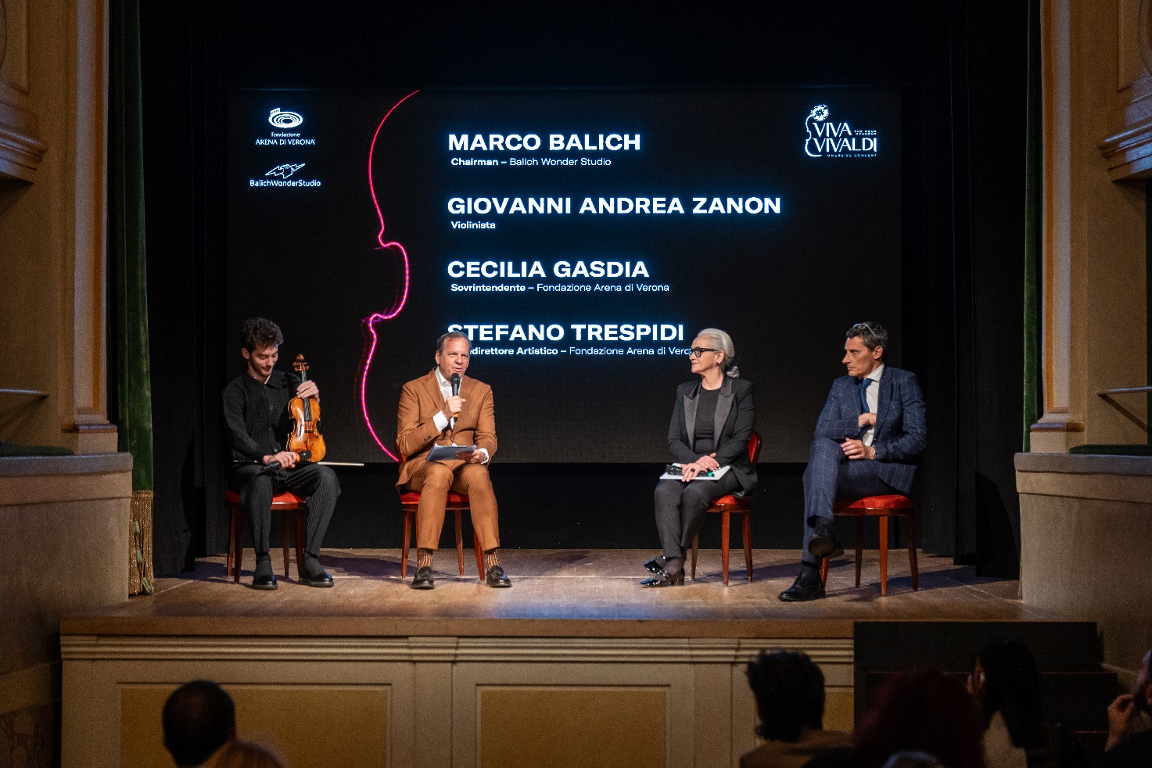

A WORLD PREMIERE OF A GRAND VISIONARY, MULTI-SENSORY CONCERT
WITH THREE-DIMENSIONAL PROJECTIONS CELEBRATING THE FOUR SEASONS BY VIVALDI.

Violinist Giovanni Andrea Zanon and the Arena di Verona Orchestra
in a project by creative director Marco Balich

Special tickets at 28 euros for the under-30s
To celebrate the 300th anniversary of the publication of Antonio Vivaldi's “The Four Seasons”, the Fondazione Arena di Verona and Balich Wonder Studio are unveiling the revolutionary performance “Viva Vivaldi. The Four Seasons Immersive Concert” to be held at the Arena di Verona on 28 August.

On the one hand, the sacredness of music with the Fondazione Arena di Verona, known throughout the world for the quality of its productions. On the other, the cutting-edge technology of Balich Wonder Studio, leaders in live entertainment and accredited worldwide for Olympic Ceremonies from Rio 2016 to Fifa Qatar 2022.
300 years after the creation of the Venetian genius, an imaginative reinterpretation of ‘The Four Seasons’ in which nature and music are celebrated through technology, continuing the tradition of the Arena di Verona, which for centuries has placed human genius and its vocation for beauty at the centre.
Conceived by Marco Balich and co-produced by the Fondazione Arena di Verona, the performance will be bringing to the stage the magical alchemy of a 29-piece orchestra, strictly faithful to Vivaldi's original score and the contemporary language of immersive technology applied to the codes of classical music. The show will feature the young Giovanni Andrea Zanon, violinist and star of the classical music scene and winner of the most prestigious international competitions, together with the professors of the Arena di Verona Orchestra.

A new visual language that celebrates the poetic contamination of music, images, light and special effects to create an unexpected symbiosis between classical music and visual narration. Viva Vivaldi is an ode to our planet Earth, to nature, its beauty and wonders, but also to the delicacy of its fragile ecosystem, seen through the passage of the four seasons.

Thanks to a sophisticated technological system that combines transparent LED screens with evocative visual and lighting effects, the concert will be accompanied by three-dimensional video content that will emerge from the stage above the audience, projecting the overwhelming power of classical music. A new and unexpected emotional dimension that transcends the boundaries of space and time and will allow the audience to perceive before their eyes the sublime beauty of music and the extraordinary power of nature.

CECILIA GASDIA, General Manager of Fondazione Arena di Verona, explains: ‘With an eye to the future and the new generations, we are kicking off the Arena di Verona's new century. And we create new opportunities of the highest level to bring young people closer to classical music. For the first time, this technology will land in an open-air theatre, a unicum that will make its world debut in the Arena’.

STEFANO TRESPIDI, Deputy Artistic Director of Fondazione Arena di Verona, comments: ‘The stage of the Arena is perfect for new experiments and contaminations, as Viva Vivaldi will be, a mix of tradition and innovation. Classical music will merge with the most extraordinary technologies to create something unique. An unmissable show especially for young people for whom a concessionary ticket is reserved’.

MARCO BALICH, Chairman of Balich Wonder Studio, adds: ‘We love challenges and firsts. With the Balich Wonder Studio team, we want to take creativity to unexplored places. This visual music show combines images and music for the first time and is a perfect opportunity to reflect on nature, time and the beauty of our world’.

The show, an original format created by Marco Balich, sees the participation of internationally recognised Italian talents: Claudio Sbragion, Creative Director, and Stefania Opipari, Co-Creative Director, flanked by Rino Stefano Tagliafierro, Video Content Art Director, and the Moving Dots studio that handled Video Content Production.

Tickets for the Viva Vivaldi show are available at www.arena.it and in the TicketOne circuit.
Special under-30 promotion: €28 ticket in all sectors.

Box Office
Via Dietro Anfiteatro 6/B, 37121 Verona
Open Monday to Friday 10.30-16.00 | Saturday 9.15-12.45
biglietteria@arenadiverona.it
Call center (+39) 045 800.51.51
www.arena.it
TicketOne pre-sale points

